# **Movie Recommendation System**

## **Introduction**

A recommendation system is any system that automatically suggests content, products or services which should interest customers based on their preferences. An example of a movie recommendation system is Netflix.

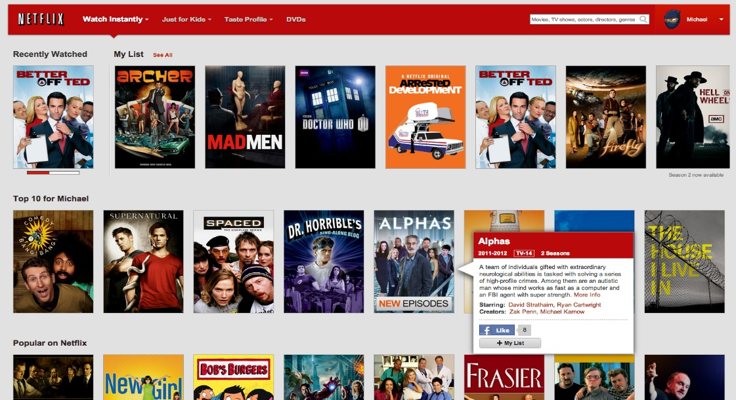

Recommendation system help to increase the site’s page views, dwell time, click-through rate, and retention. It helps to generate more advertising revenue.

## **Datasets**

1. MovieLens dataset

Source: https://grouplens.org/datasets/movielens/latest/

1. TMDB dataset

Source: https://www.kaggle.com/tmdb/tmdb-movie-metadata/

## **Approach**

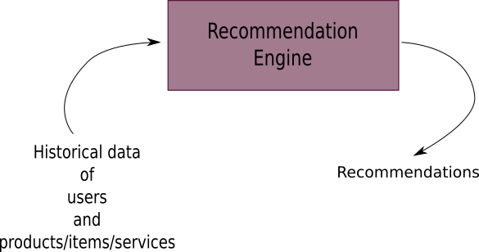

We are building a system where we predict or suggest movies based on the user historic data. Five different recommender types are used:

1. **Simple Recommender**: Offers a generalized recommendation by recommending movies that are extremely popular among users and will have a high probability of being liked by everyone. It will be using the IMDb's weighted rating formula to recommend.
2. **Correlation Recommender**: Offers recommendations based on the correlation between the ratings of the movies.
3. **Content-Based Recommender:** Recommendation based on user view history. It looks for similar features like genres, cast, keywords, director or all combined. It generates cosine similarity score for recommendations.
4. **Collaborative Filtering:** Recommendation based on like by similar users. All the features about items and users come from the community of users. We will be using Model-Based where it will try to fill out the matrix of preferences of users for the movies and try to predict what rating they will give to the missing items and suggest them.
5. **Hybrid Recommender**: Combines Content-Based Recommender and Collaborative Filtering to combine the strengths of both recommender systems.

## Result

We implemented 5 different recommendation systems based on different algorithms. We can clearly see that each of them has their own complexities and how they differ a lot from each other.

Content-Based Recommender and Collaborative Filtering are the most popular types and widely used recommending engines. The more data there is to collect, the more robust the recommendation model will be, and it will become extremely appealing.